

|  |  |  |  |  |  |  |  |  |
| --- | --- | --- | --- | --- | --- | --- | --- | --- |
|  | | | | | | | | |
|  | | Assignment . 1 | | | | |  | |
|  |  | | | | | | |  |
|  | | | |  |  | | | |
|  | | | | MujtabaSP22-BSE-036 |  | | | |
|  | | | | Oct 16, 2022—Programming Fundamentals—Sir Rizwan Rashid |  | | | |
|  | | |  | | |  | | |

QUESTION . 1

1. ***Write JAVA statements that can produce Syntax Errors. Give three different examples and write the names of errors.***
   1. Syntax errors are for example when spelling mistakes occur in variable names, or missing semicolons, or any other thing that violates the grammar of a programming language.
   2. Examples:

int x, y;  
x = 10 *// missing semicolon (;)*z = x + y; *// z is undefined, y in uninitialized.*func() *// this function is never defined*

1. ***Write JAVA statements that can produce Logical Errors. Give three different examples and briefly explain the reason (1-2 lines).***
   1. A logic error is when your program compiles and executes, but does the wrong thing than expected.
   2. Examples:

int tmp = a / b; *//where a % b is expected.*System.out.print("Success"); *// where "Error" is expected.*func(); *// wherer calling foo() is expected*

1. ***Write JAVA statements that can produce Run Time Errors. Give three different examples and briefly explain the reason (1-2 lines).***
   1. Runtime errors occur when a program does not contain any syntax errors but asks the computer to do something that the computer is unable to reliably do.
   2. Examples:

int myInt = scanner.nextInt(); *// but user enters a String*int x = y / z; *// But the value of z here is 0, so division by 0 occurs*array[11] = 5; *// But index 11 is out of bounds of this array*

1. ***Correct syntax errors.***
   1. Program after correcting error (corrected errors are written in comments):

public class Code {  
 public static void main(String[] args){  
 final int PRIME = 1; *// Defined constant* final int ONE = 1; *// Defined constant* int count = 1; *// Corrected declaration with type int* int sum = count + PRIME; *// Corrected declaration with type int* double x = 25.67; *// Corrected declaration with type double* int newNum = count * ONE + 2;  
 sum += count; *// Corrected assignment* x = x + (double)(sum * count); *// Casted type to prevent error* System.out.println(" count = " + count + ", sum = "  
 + sum + ", PRIME = " + PRIME);  
 }  
}

* 1. Output of this program (after running): count = 1, sum = 3, PRIME = 1

QUESTION . 2

1. ***Write - comments (Single Line, Multiline), - Special symbols (three) - Reserve words (three) - Identifier (predefined and defined by user) (three each) - Standard Input Stream Object - Standard Output Stream Object.***

|  |  |
| --- | --- |
| Comments | */*This program will calculate product of three numbers */*  *// first number*  *//product of numbers*  Etc etc |
| Symbols | = * ; |
| Reserve Words | public static void int class |
| Identifier | num1, num2, num3, result, etc etc |
| Input Stream | There is no input stream used here. |
| Output Stream | System.out is the output stream here. |

QUESTION . 3

1. ***Java statements that accomplish given tasks (code below is the solution):***

public class Code {  
 public static void main(String[] args) {  
 int x, y;  
 x = 10; char ch = 'B'; y = 1;  
 x += 5; double payRate = 12.50;  
 int firstNum = 100, tmpNum;  
 tmpNum = firstNum;  
 int s_tmp = x; x = y; y = s_tmp;  
 System.out.print((double)x); System.out.print((double)y);  
 System.out.print((double)(x+12/y-18));  
 char grade = 'A'; int n1 = 1, n2 = 2, n3 = 3, n4 = 4;  
 x = (int)z;  
 }  
}

1. ***Suppose a, b and c are int variables and a = 5, b = 6, d = 2. What value is assigned to each variable after each statement executes? If a variable is undefined at a particular statement, report UND (undefined)***

|  |  |  |  |  |
| --- | --- | --- | --- | --- |
| statement | a | b | c | d |
| a = (b++) + 3 * ++d; | 15 | 6 | UND | 3 |
| c = 2 * d + (++b) + a; | 5 | 7 | 16 | 2 |
| b = 2 * (++c) - (a++); | 5 | UND | UND | 2 |
| d = d++ + d + b++ + b; | 5 | 6 | UND | 18 |

1. ***S*** ***uppose a, b, and sum are int variables and c is a double variable. What value is assigned to each variable after each statement executes? Suppose a = 3 , b = 5 , and c = 14.1***

|  |  |  |  |  |
| --- | --- | --- | --- | --- |
| Statements | a | b | c | sum |
| sum = a + b + ( int) c; | 3 | 5 | 14 | 22 |
| c /= a; | 3 | - | 4.7 | - |
| b += (int) c - a; | 3 | 16 | 14 | - |
| a *= 2 * b + (int) c; | 44 | 5 | 14 | - |

QUESTION . 4

1. ***Daily Driving Cost***

*// CALCULATES DAILY DRIVING COSTS*import java.util.Scanner;  
public class Code {  
 public static void main(String[] args){  
 Scanner s = new Scanner(System.in);  
 System.out.print("Enter miles per day: ");  
 double milesPerDay = s.nextDouble();  
 System.out.print("Enter gasoline cost per gallon: ");  
 double costPerGallon = s.nextDouble();  
 System.out.print("Enter miles per gallon: ");  
 double milesPerGallon = s.nextDouble();  
 System.out.print("Enter parking fee per day: ");  
 double parkingFeePerDay = s.nextDouble();  
 System.out.print("Enter tolls per day: ");  
 double tollsPerDay = s.nextDouble();

double costPerMile = costPerGallon / milesPerGallon;  
 double totalCost = (costPerMile * milesPerDay)  
 + parkingFeePerDay + tollsPerDay;  
 System.out.print("Your total driving cost per day is: "  
 + totalCost);  
 }  
}

Output:

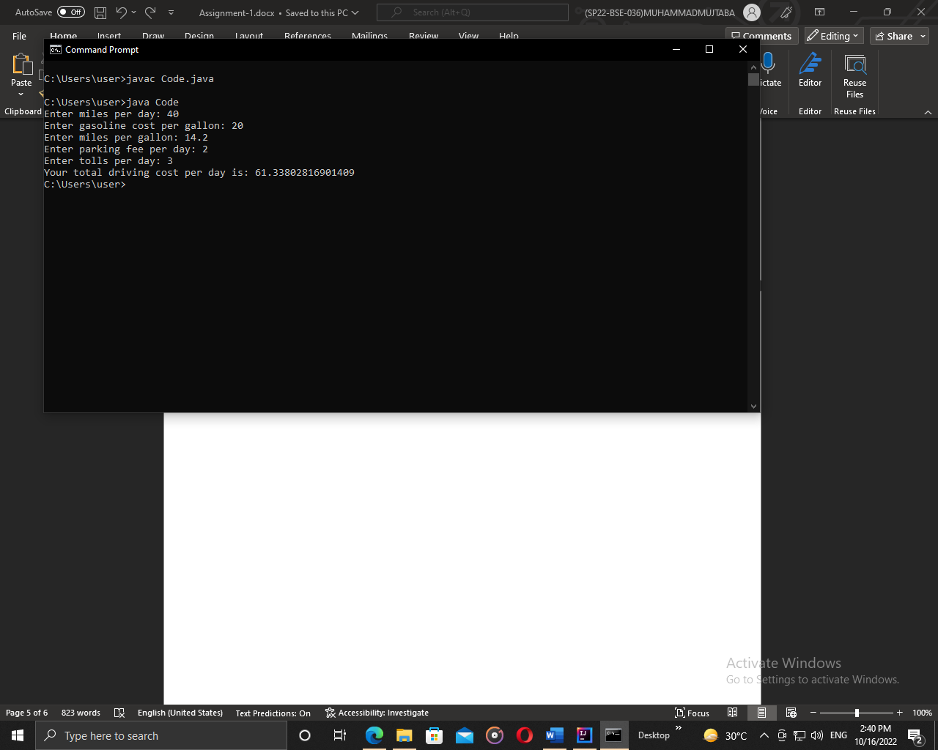

QUESTION . 5

1. ***Reverse of a number***

*// REVERSE OF A NUMBER*import java.util.Scanner;  
  
public class Code {  
 public static void main(String[] args){  
 Scanner s = new Scanner(System.in);  
 System.out.print("Enter a 5-digit number: ");  
 int n = s.nextInt();  
 int reverse = 0;  
 while(n != 0) {  
 int remainder = n % 10;  
 reverse = (reverse * 10) + remainder;  
 n = n / 10;  
 }  
 System.out.println("The reverse number is: " + reverse);  
 }  
}

Output:

